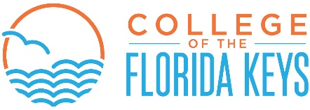

FINANCIAL AID PROGRAMS

Federal Pell Grant

The Federal Pell Grant is a need-based federal grant for students seeking their first undergraduate degree. Financial need is determined by the Expected Family Contribution (EFC) from the student’s processed FAFSA (Free Application for Federal Student Aid). The annual award amount is determined by the EFC and enrollment hours. Students may receive funding only for courses that are required for the program(s) of study and a maximum of 30 credit hours of required college-preparatory coursework. Students must be enrolled in an eligible degree or certificate program.

The final Pell grant award will be determined by the number of hours attended on the financial aid census date each term. Should a student reduce the number of enrolled credit hours, he/she will then owe the College for the dropped course(s) and any lab fees or book charges not covered by the adjusted Pell award. All Pell students are advised to speak with a financial aid staff person prior to dropping and/or withdrawing from a course.

Federal Supplemental Educational Opportunity Grant (FSEOG)

FSEOG is a need-based federal grant awarded to undergraduates seeking a first undergraduate degree in an eligible program who have demonstrated exceptional financial need as determined by the results of the FAFSA. Priority is given to students with an Expected Family Contribution (EFC) of zero who apply for financial aid early. Students must enroll for a minimum of six credit hours in order to qualify. FSEOG is awarded later in the term. Limited funding is available each year for this program, and funds are available on a first-come, first-served basis. The award is in addition to the student’s Pell Grant award.

Florida Student Assistance Grant (FSAG)

FSAG is a need-based State of Florida program for students who meet Florida residency requirements. To qualify, a student must be seeking a first undergraduate degree, be enrolled in an A.A. or A.S. degree program, qualify for a Pell grant, and be enrolled for a minimum of six credits per term. The amount awarded for part-time, three quarter time, and full-time enrollment is determined by the State of Florida on an annual basis. FSAG is awarded by the College on a first-come, first-served basis, after the close of the regular drop/add period each term. Initial eligibility is determined by the results of the Free Application for Federal Student Aid (FAFSA). The FSAG is in addition to the student’s Pell Grant award.

